Simple Twist of Fate – Bob Dylan

4
4 G | Bm | G7 | C |

Cm | G D C | G C | G :||

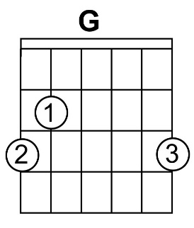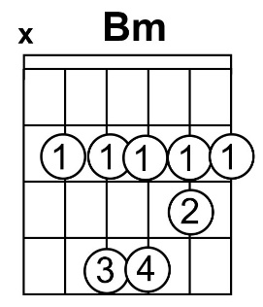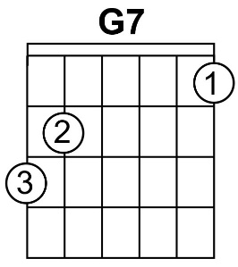

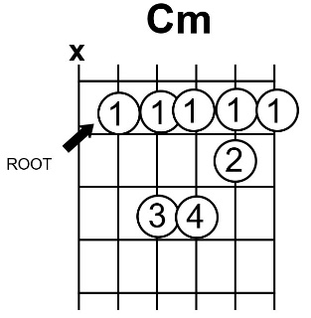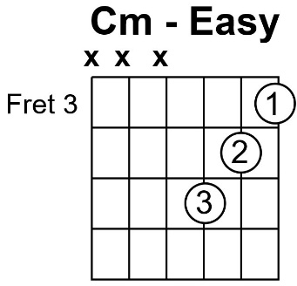

They sat together in the park
As the evening sky grew dark
She looked at him and he felt a spark
Tingle to his bones
'Twas then he felt alone
And wished that he'd gone straight
And watched out for a simple twist of fate

They walked along by the old canal
A little confused, I remember well
And stopped into a strange hotel
With a neon burnin' bright
He felt the heat of the night
Hit him like a freight train
Moving with a simple twist of fate

A saxophone someplace far-off played
As she was walkin' on by the arcade
As the light bust through a beat-up shade
Where he was waking up
She dropped a coin into the cup
Of a blind man at the gate
And forgot about a simple twist of fate

He woke up, the room was bare
He didn't see her anywhere
He told himself he didn't care
Pushed the window open wide
Felt an emptiness inside
To which he just could not relate
Brought on by a simple twist of fate

He hears the ticking of the clocks
And walks along with a parrot that talks
Hunts her down by the waterfront docks
Where the sailors all come in
Maybe she'll pick him out again
How long must he wait?
One more time, for a simple twist of fate

People tell me it's a sin
To know and feel too much within
I still believe she was my twin
But I lost the ring
She was born in spring
But I was born too late
Blame it on a simple twist of fate

