Black Magic Woman

4
4 Dm | |Am | |

Dm | |Gm | |

Dm | Am |Dm |Dm (Stop) :||

Barre chords:

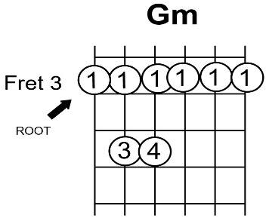
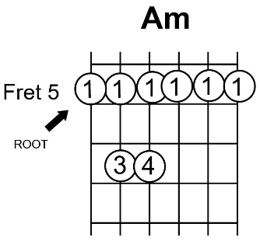
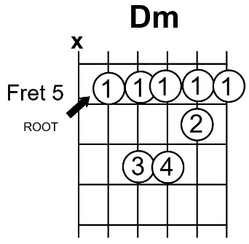

Easy chords:

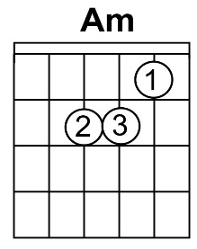
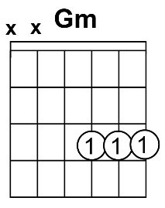
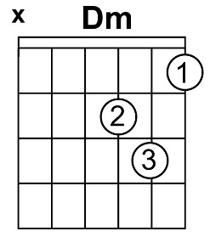

Got a black magic woman
I got a black magic woman
Yes, I got a black magic woman
Got me so blind I can't see
But she's a black magic woman
And she's tryin' to make a devil out of me

Don't turn your back on me baby
Don't turn your back on me baby
Yes, don't turn your back on me baby
You're messin' around with your tricks
Don't turn your back on me baby
'Cause you might just break up my magic stick

You got your spell on me baby
You got your spell on me baby
Yes, you got your spell on me baby
You're turning my heart into stone
I need…
Yes, I need you so bad
Well, I need you darling
Yeah, I need you darling
Yes, I want you love me
I want you love me
Whoa, I want you love me, ah
Whoh, yeah Oh, whoa, baby
Yes, I need your love

